 | Theme | Thanksgiving | Thanksgiving Day
 | Date | Nov 25 | Nov 27
9:00 – 9:10am | Table Activity | - Thanksgiving Color pg  - Apple Pie Playdoh  - Indian Corn | No  School
9:10 – 9:30 am | Circle Time | - Calendar / Weather  - “What is Thanksgiving?” by Michelle Medlock Adams  - Friendship Necklaces | 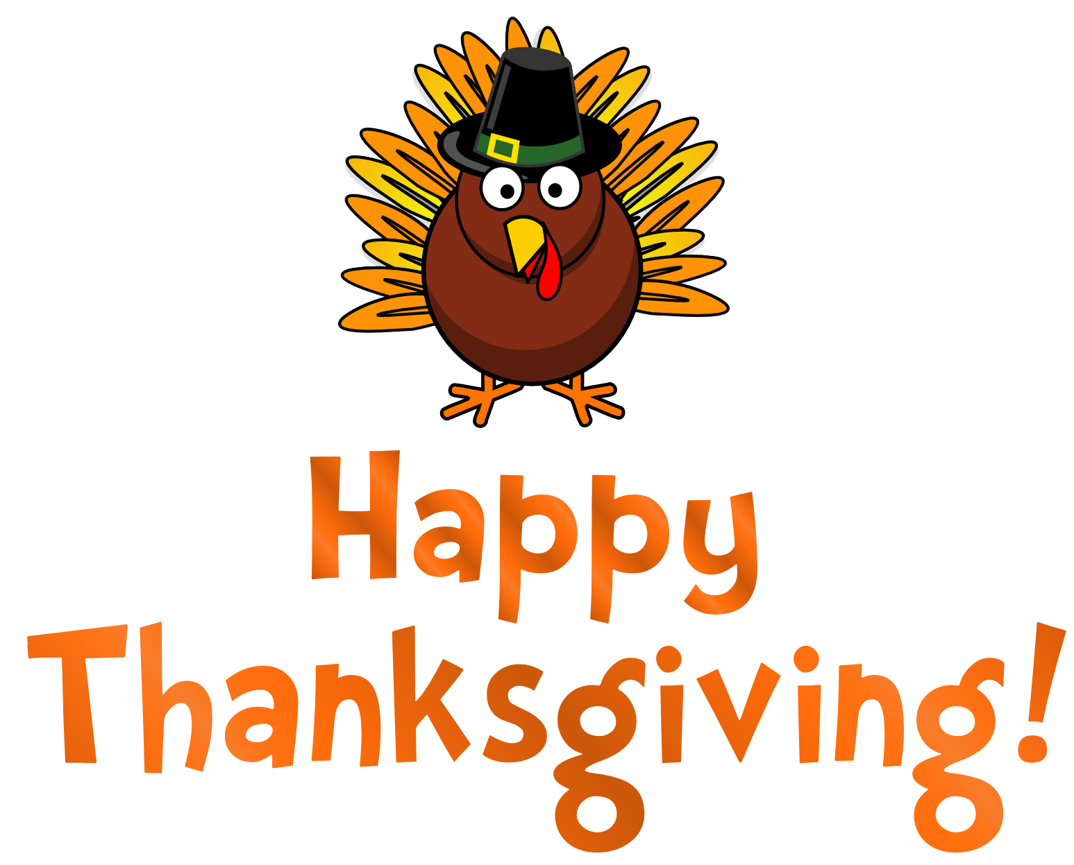
9:30 – 10:45 am | Centers/ Exploration | Group 1 (Sensory):  - Lego Print Indian Corn  Group 2 (Fine Motor):  - I am Thankful for… plate wheel  Exploration:  - Trace the line to pumpkin pie  - Explore | Group 1 (Sensory):  -  Group 2 (Fine Motor):  -  Exploration:  -
10:45 – 11:00 am | Circle time | - Read Aloud: “Pete the Cat: The First Thanksgiving” by James Dean  - Movement Song (Act like turkeys)
11:00 – 11:15 am | Bathroom / Snack | Friendship Feast (Each child brings in 2 cups of their favorite snack)
11:15 – 11:30 am | Recess | Gross Motor & Social Skills

